Day 6 - 31st May 2025

Your Doc name: Linux

Id: hkumarzh (109940031)

Name: Hemant Kumar

Q. List of regular expression symbols:

1. . - Matches any single character except newline
2. ^ - Start of string
3. . $ - End of string
4. \* - Matches 0 or more occurrences
5. + - Matches 1 or more occurrences
6. ? - Matches 0 or 1 occurrence
7. \ - Escapes special characters
8. [a-z] - Matches any lowercase letter
9. [A-Z] - Matches any uppercase letter
10. [0-9] - Matches any digit
11. [a-zA-Z] - Matches any letter

Q. If you are aware of Linux OS.. can you tell me the feature of Linux.

Linux is open source free to use OS. It has strong security system, built-in firewalls. It can also have multiple users; it has strong memory management. Comes with multiple distributions and highly customizable. Many built-in development tools and other tools support.

Q. What is Kernal? can you explain about it in your words.

Kernal is basically a mediator between software and hardware. It decides and allocates memory whenever we open any software as per software requirement and hardware availability. Controls security permissions, manage drivers etc.

Q. BASH in linux. Fullform and explanation.

BASH stands for Bourne Again Shell. Basically, it is default command prompt of the Linux system. We can control task on linux system just by writing commands in the BASH terminal.

Q. What do you think is the difference between Linux and Windows

Linux is free to use OS unlike windows which are paid. It is openly available with better security, high performance. It has multiple distributions. Terminal is more powerful than windows cmd. Memory management is better.

Q. What are the basic components of Linux? Describe each in detail with diagrams.

Kernal – Which work as heart of system ensuring all the communication between hardware and software. Managing drivers, Memory management etc.

Shell - Command interpreter which executes commands. It communicates with Kernal to perform action.

System Libraries - this contain pre-compiled functions which are used for applications/ executions for example C language libraries.

System utilities – Like file operations, network management, system maintenance etc.

Hardware layers – hardwires components, drivers

Q. Is it legal to edit Kernal? when do you think we have to in case?

Yes, since it is opensource and source code is available to all, we can edit Linux Kernal. This is mostly done, when different hardware compatibility require or driver support require etc.

Q. What is LILO? Explain

LILO is basically Linux Loader which loads the Operating system to the memory. It comes in picture after BIOS (boot loader) and can load multiple OS in memory if configured. It is a software program loaded in hard disk of the system.

Q. What is shell? How many shells are there and what are they? can you explain.

It is command interpreter. It basically interprets the command to kernel to execute the function.

Types –

* Bourne Shell (sh) - The original Unix shell that provides basic command interpretation and shell scripting capabilities. Features minimal scripting elements and serves as a foundation for other shells, still used for basic scripting tasks.
* Bash (Bourne Again Shell) - Advance version of sh with improved features like command history, tab completion, and command-line editing.
* C Shell (csh) Designed with C-like syntax making it familiar for C programmers to write shell scripts. Offers command history, job control, and command-line aliases but less suitable for complex scripting.
* Korn Shell (ksh) Combines features of Bourne shell and C shell with advanced programming capabilities. Provides robust scripting features, array handling, and floating-point arithmetic while maintaining sh compatibility.
* Z Shell (zsh) Modern shell with advanced features like improved tab completion, spelling correction, and themed prompts. Highly customizable with plugin support and offers compatibility with bash while providing enhanced interactive features.

Q. What is swap space?

It is virtual memory, or we can say, when we use our hard drive to extend the ram capacity of the system.

Q. What is Mount? how do you mount and unmount file system in Linux?

Process of attaching drive or file system to directory.

To mount we can use - mount filesystem1 filesystem2 , here filesystem1 will be mounted to filesystem2. We can also use with permission of read, read write etc.

To unmount – unmount filesystem1

Q. What is chmod command? how to use it?

Chmod is basically change mode command which handles permission control on file system.

Example chmod 777 filename .Here 7 means all the permission or say full access given which read (4),write(2), execute(1) overall 7.

Q. Can you add a new user account? Crate a new user in different ways and paste ss

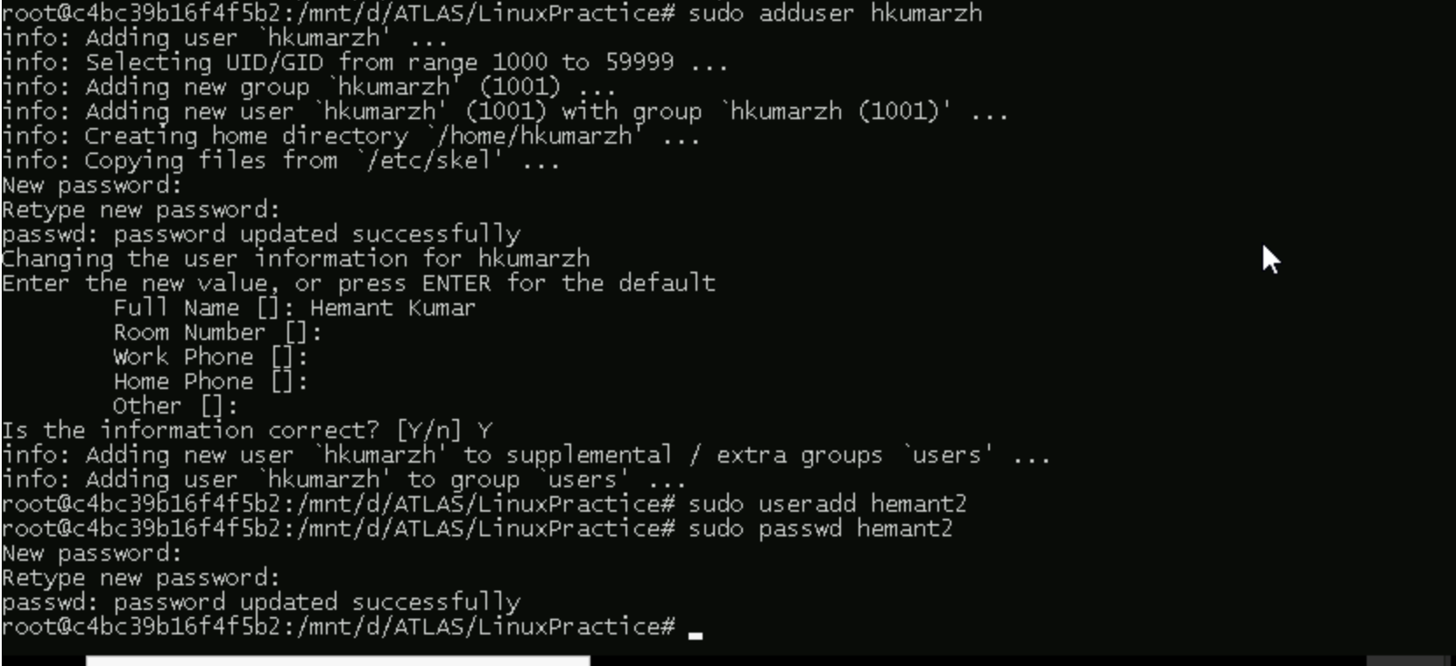

Q. Can you change the password of a user?

How do you do that? Plz share ss

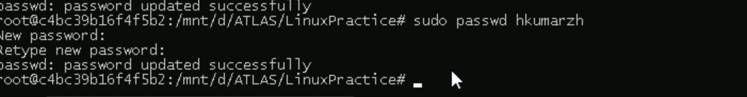

Q. What is diff between Process and Thread?

Process: A process is an independent program execution unit that operates with its own dedicated memory space, resources, and Process ID (PID), making it completely isolated from other processes. Each process contains its own program counter, stack, and heap memory, ensuring that one process cannot directly access or modify another process's memory space.

Thread: It is part of process execution. Within one process multiple threads can run sharing same memory space. This is basically use for parallel processing.

Q. Grep Commands

1. Commands used -m1, --color, -i (max count 1, highlight color, case insensitive)



1. Commands used -o, -oi, wc, -l, sort, -u

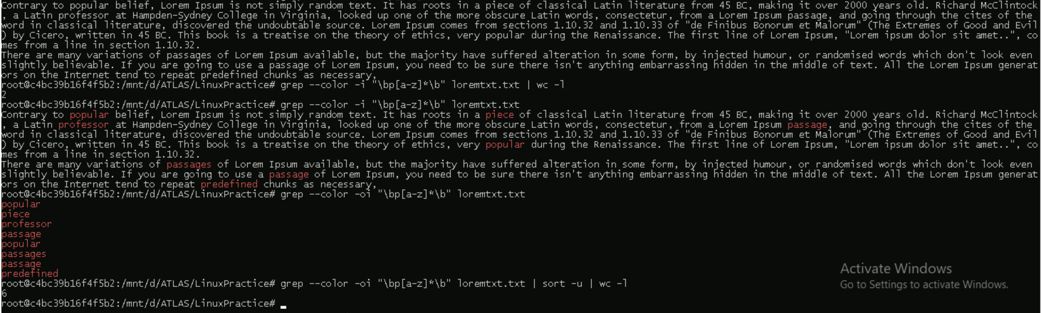



1. More commands

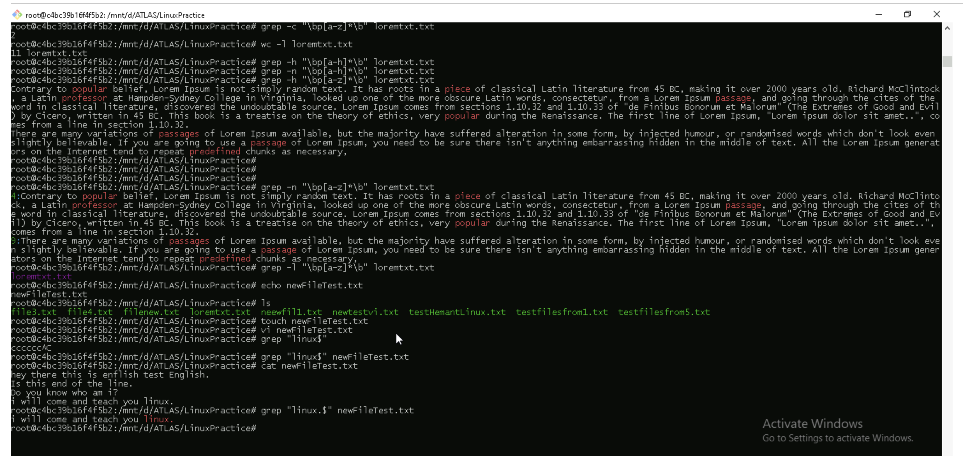

AWK commands

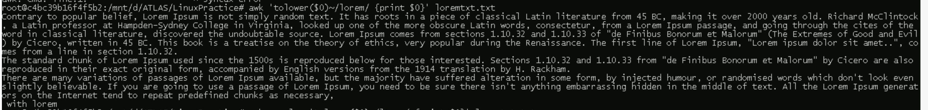

Q. What are the default permission for new file?

* Owner – read, write, execute
* Group – read
* Other - read

Q. What is the command to change the permisssion to read only for the owner, group and all other users?

Chmod 444 filename.txt

Q. Can you change the file permissions to match the following:

* owner: Read and Write. -> 6
* group: Read -> 4
* other: no permissions (None) ->0

chmod 640 filename

Q. What was the command for changing the file permissions to -rw-r-----?

chmod 640 filename

Q. Change chmod.exercises permissions to -rwxr-x—x

chmod 751 filename

Q. Change the file permissions to match the following:

owner: Read, Write and Execute ->7

group: Read and Execute ->5

other: Execute ->1

chmod 751 filename

Q. what does this do?

chown -c master file1.txt

chown – change owner

-c -> report when owner change

Master -> new owner name

File1.txt -. File for which owner is getting change

Q. Can you define what is  a process

Process is basically running instance of a program which is executed by cpu, memory has been allocated to it, resources required has been allocated to it and is having PID(process id).

Q. What is command to check foreground process and background process

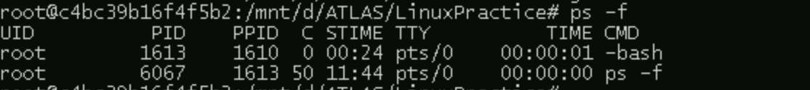

Q. Can you create a variable name with your name in it

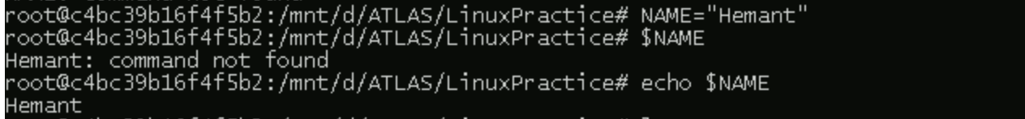

Q. Can you make it readonly?

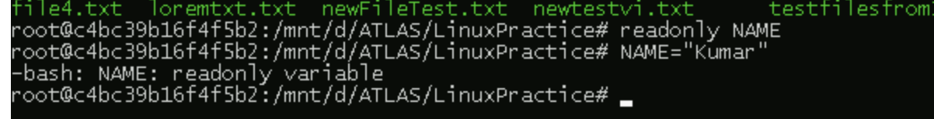

Q. unset command



Q. Array and operators

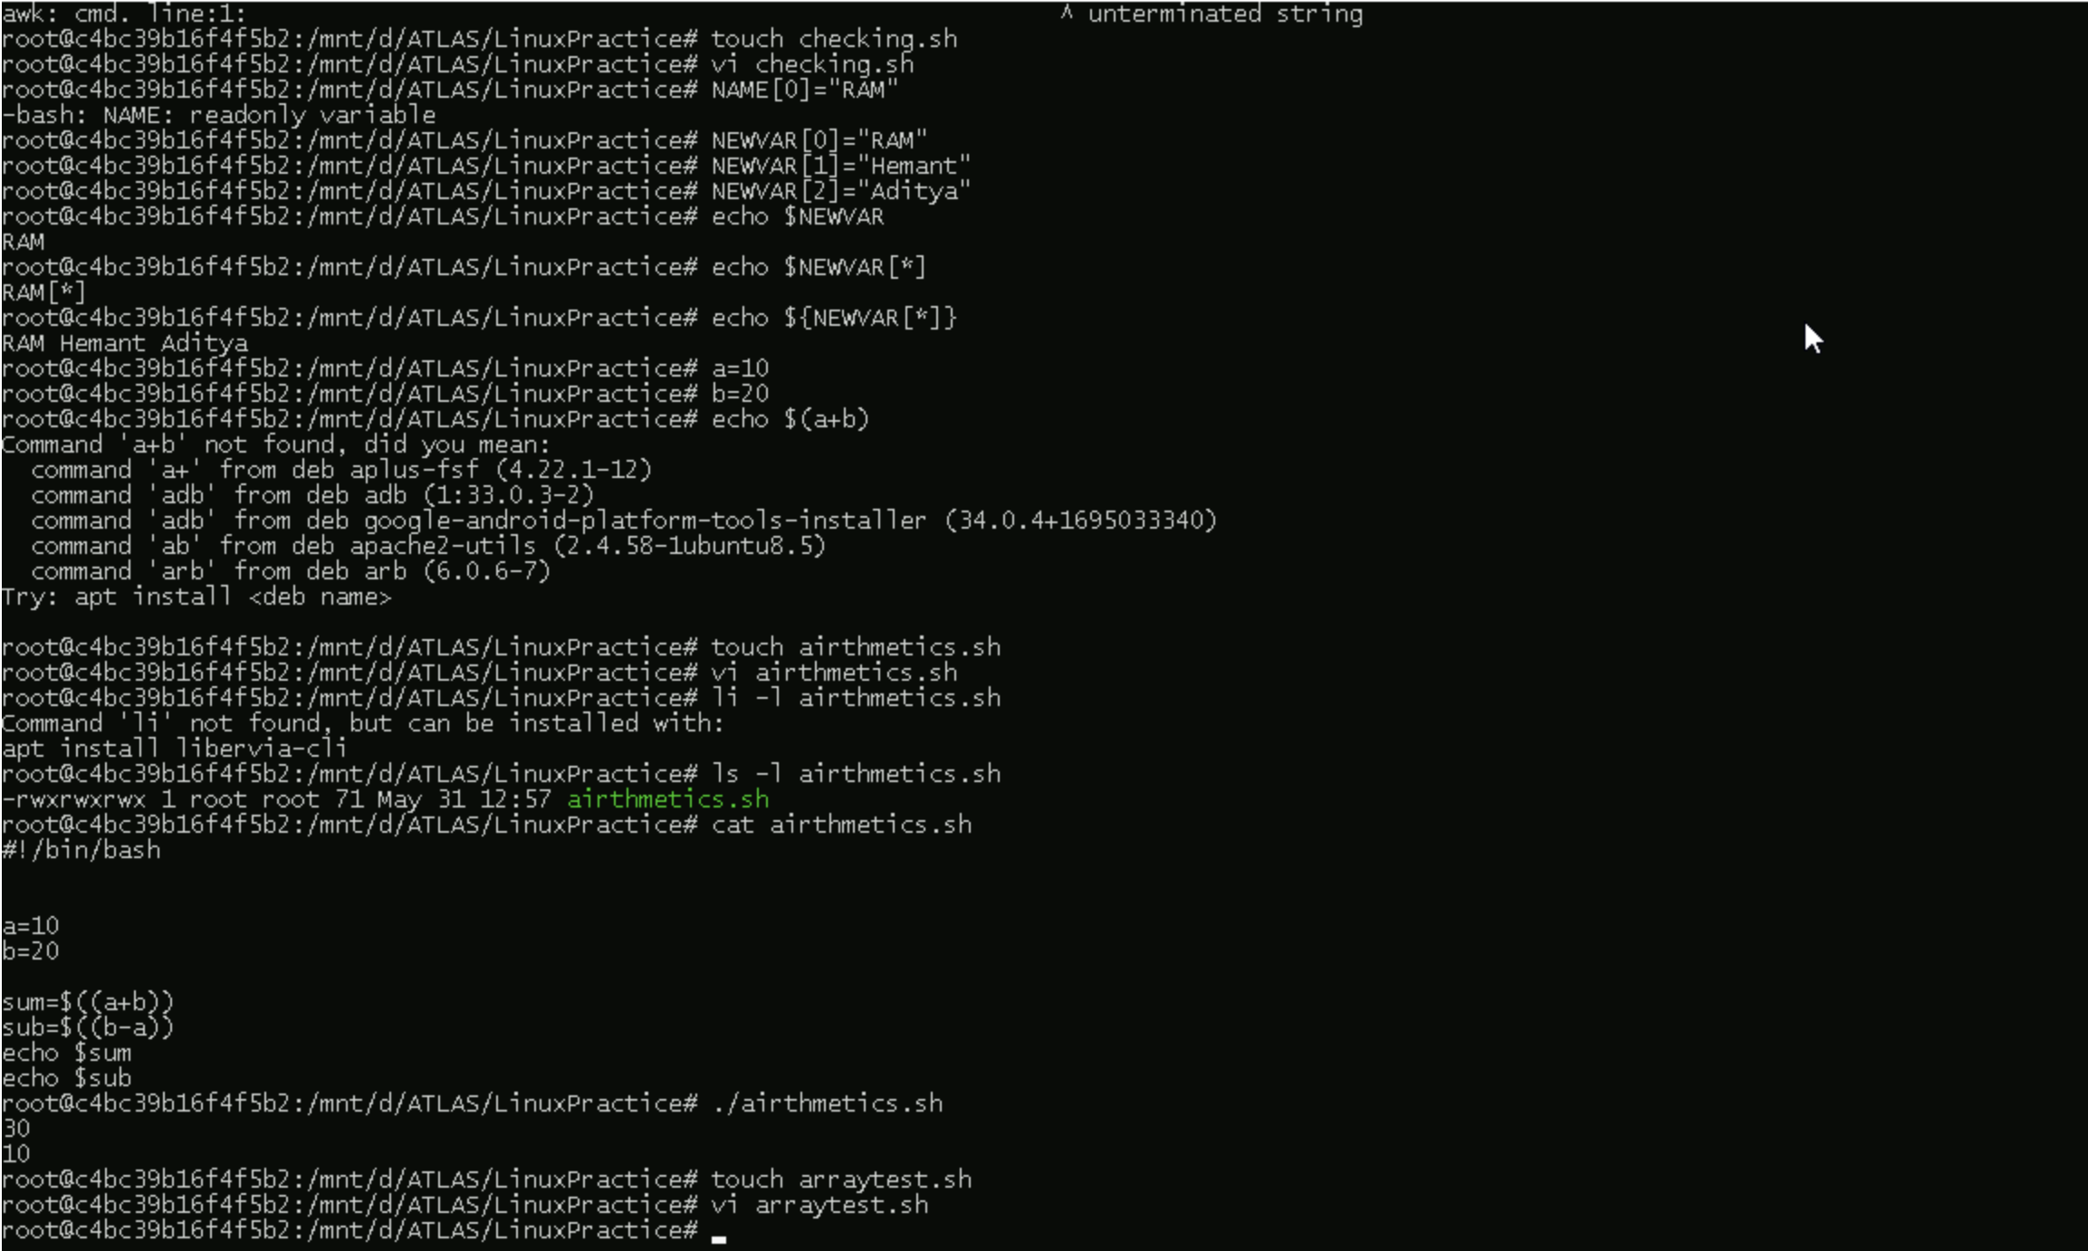

Q. What will be output of below code

a=0

while [ "$a" -lt 10 ]    # this is loop1

do

   b="$a"

   while [ "$b" -ge 0 ]  # this is loop2

   do

      echo -n "$b "

      b=`expr $b - 1`

   done

   echo

   a=`expr $a + 1`

Done

Ans – Error due to end of while loop (Done). As, shell script is case sensitive, done is right end of loop not Done.